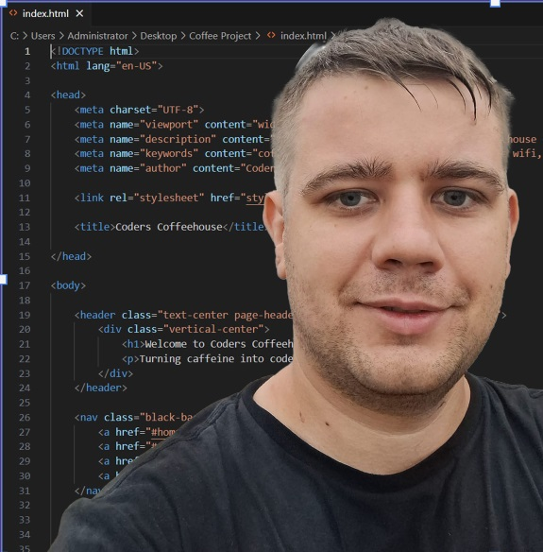

**Adrian Szmajewski**   
High Wycombe, Buckinghamshire, HP12 3BQ  
07341677097  
E-mail: [adrianszmajewski8@gmail.com](mailto:adrianszmajewski8@gmail.com) LinkedIn: [linkedin.com/in/adrian-szmajewski-45ba6729a](https://www.linkedin.com/in/adrian-szmajewski-45ba6729a)

**Profile**

A highly motivated individual with strong project management skills and a foundation in software development, gained through the completion of The Skills Network Level 3 Skills Bootcamp in Software Development. Experienced in managing complex processes, maintaining meticulous attention to detail, and delivering high-quality outcomes. Seeking a Qualifications Developer role to apply my problem-solving abilities, communication skills, and technical expertise in a regulated environment, contributing effectively to the design, development, and maintenance of qualifications.

**Education**

**The Skills Network**  
*Level 3 Skills Bootcamp in Software Development*  
June 2023 - September 2023

* Developed proficiency in Python, JavaScript, SQL, and web development principles.
* Completed projects involving software engineering, database management, and programming.
* Enhanced attention to detail and project management skills through the structured software development process.

**Technical & Professional Skills**

* **Project Management:** Highly organized and efficient, with strong multitasking abilities and experience managing processes to meet strict deadlines.
* **Communication:** Excellent written and verbal communication skills, with experience collaborating across departments and external stakeholders.
* **Regulated Environments:** Experience in adhering to industry standards and compliance, ensuring processes meet regulatory requirements.
* **Data Management:** Experience maintaining accurate records, using databases to manage, retrieve, and ensure data integrity.
* **Software Development:** Proficient in Python, JavaScript, SQL, MySQL, HTML, CSS, React.
* **Tools & Technologies:** Git, GitHub, Visual Studio Code, AutoCAD (2D Intermediate to Advanced).
* **Soft Skills:** Strong attention to detail, problem-solving, adaptability, team collaboration.

**Professional Experience**

**Productive Labour**, High Wycombe, Buckinghamshire  
*Worker*  
September 2021 - Present

* Worked collaboratively within a team to achieve production goals, ensuring adherence to high standards.
* Developed organizational skills by managing multiple tasks and ensuring timely completion of projects.

**Hypnos Beds**, Princes Risborough, Buckinghamshire  
*Frame Maker/Upholsterer*  
August 2015 - August 2021

* Managed projects that required precision and attention to detail in crafting and upholstering bed frames.
* Documented processes for future reproducibility and worked with team members to refine production efficiency.

**Correct**, Ociaz, Poland  
*Frame Maker/Upholsterer*  
August 2014 - August 2015

* Maintained accuracy in producing bespoke furniture and upholstery, focusing on quality control and process improvement.

**Key Projects**

**Personal Portfolio Website**

* Built a responsive portfolio website using HTML, CSS, and JavaScript to display professional projects and skills.

**Database Management System**

* Designed and implemented a database management system using SQL, creating a streamlined interface for data entry and retrieval.

**Additional Skills & Certifications**

* **Languages:** Fluent in English and Polish
* **Certifications:**
  + The Skills Network Level 3 Skills Bootcamp in Software Development
  + TQUK Level 2 Certificate in Principles of Team Leading (RQF)
  + London Software Training Certificate in AutoCAD 2D Intermediate to Advanced
* **Soft Skills:** Strong work ethic, flexibility, attention to detail, and the ability to work independently or as part of a team.